**Project development and delivery spirit-1**

|  |  |
| --- | --- |
| Date | 22 September 2022 |
| Team ID | PNTIBMVv23 |
| Project Name | IOT Based safety gadget for child safty monitoring and notification |
| Maximum Marks | 4 Marks |

**PROPOSED METHODOLOGY**

**The Children safety and security is more and most important one to build a best and powerful nation. Hence the children security policies have to strengthen to save the children from any problems. In that perspective, many technologies are deployed, and devices are made to ensure the safety zone of the children. To improve the security services here, we proposed the ideas to get accurate results about child safety. It came with only manual approaches for providing information to the parents through phone calls or postal service. But it may not be sufficient one to satisfy the expectations of people who involved children security.**

Traditional Child Safety and Security System

The problems in traditional approaches are listed below.

Manual operations.

Delayed Message Service.

No Tracking facility.

No Direct Communication with Children.

To overcome all such problems the recent innovations and technologies are recommended to improve the safety measure on children security. The Smart watches for kids can provide maximum services what parents need to know from their children place. But it can give only main areas which found in the GPS system. Hence, few more features to be improved with the smart watch to provide updated information about the children visited the different places in the school campus. The smart watch should sense system should connect with child school ID card for sensing and tracking the children movements inside the school campus using RFID tags. This can be achieved when RFID tag connecting module integrates with children smart watches. Then the smart watch can observe the movement of the child whenever the RFID scanning device communicates with the kids‘ smart watches. The dedicated module in smart watch will process the signal, and it sends the details to parents with associated attribute fields. The above attributes are collected through Smart watch and those will be sent to the parent‘s smart phone. In the parent‘s smart phone the respective mobile app will process the incoming data and generates the result according to the users‘ expectation.

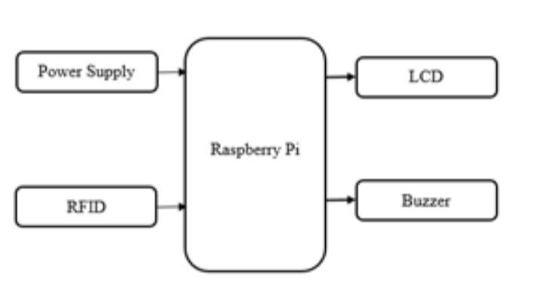

Working

The working of this models starts when student unique ID which I sin RFID form scans in school bus unit and sends a notification to parents and then when he enters to school the same RFID is scanned by the school reader unit which identifies the student entry and exit of the student. This process repeats for 2 times in a day when student enters and leaves the school. Whenever the student ID is missing from the data base the device sends alert message to parents the same is displayed on the LCD and buzzer for local reference.

HARDWARE DESCRIPTION

RFID Module

RFID means Radio frequency identification. The RFID system involves a tag and reader. RFID tag may also call an RFID chip. When card scanned ,the antenna within the tag picks up the radio wave and sends a response back to the reader. In this paper, we use RFID for unique identification.

LCD

LCD is liquid crystal display technology works by blocking light. Specifically, it is made of two pieces of polarized glass that contain a liquid crystal material between them. A backlight creates light that passes through the first substrate. It is used for display purpose. 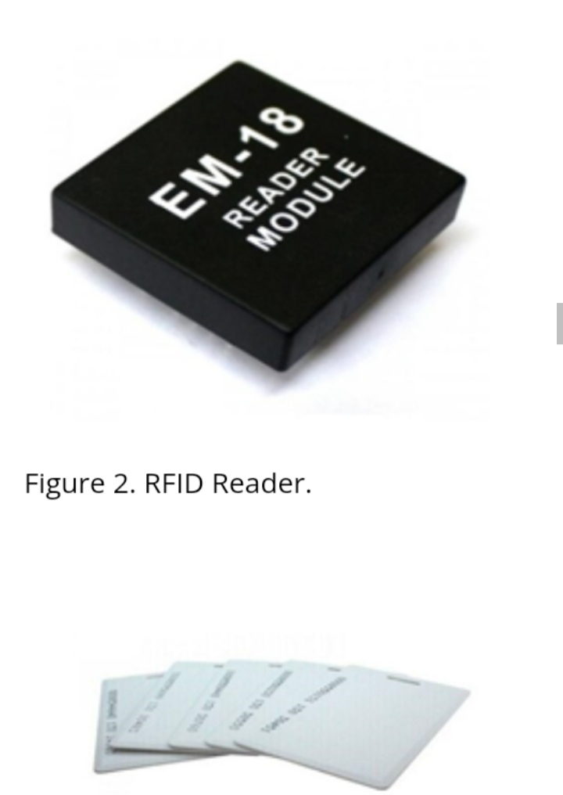LCD

LCD is liquid crystal display technology works by blocking light. Specifically, it is made of two pieces of polarized glass that contain a liquid crystal material between them. A backlight creates light that passes through the first substrate. It is used for display purpose.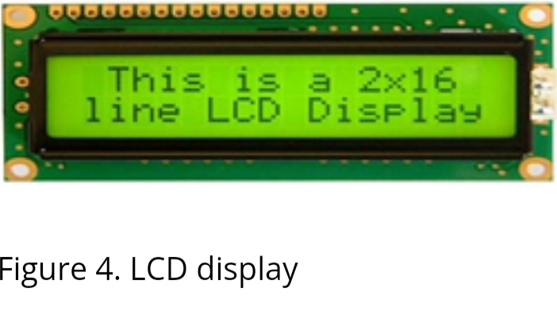CONCLUSION

Hence the children security policies must strengthen to save the children from any problems. In that perspective, many technologies are deployed, and devices are made to ensure the safety zone of the children. To improve the security services here, In this paper a system for children’s safety is developed For children safety purpose. we developed a IOT based child safety using raspberry. Students having a RFID based cards which used for authentication. Whenever student enters in school bus .Raspberry sends a message notification to parents, principal.